**NATIONAL UNIVERSITY OF COMPUTER AND EMERGING SCIENCES-FAST**

**KARACHI CAMPUS**



**PROJECT NAME:**

**FOOD ORDERING SYSTEM**

**SECTION:**

**B**

**GROUP MEMBERS:**

**ALI PUNJWANI (19K-0365)**

**MUHAMMAD HUZAIFA (19K-1251)**

**AHMED GHANI (19K-1289)**

# OBJECTIVE:

The main objective of this project is to demonstrate and to evaluate a system based on some real world which have features to run the business easily.

# INTRODUCTION:

Food ordering system is consist of technologies which have a basic frontend in bootstrap and logics applied from javascript ant backend is mysql connected through php.

**ER DIAGRAM AND NORMALIZATION DIAGRAM:-**

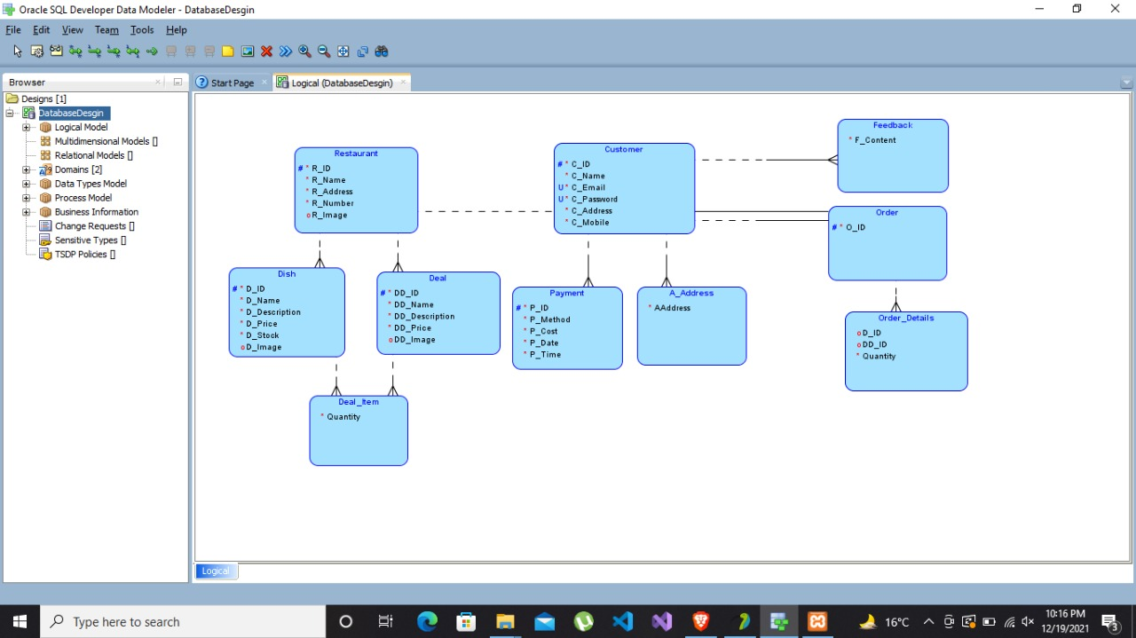

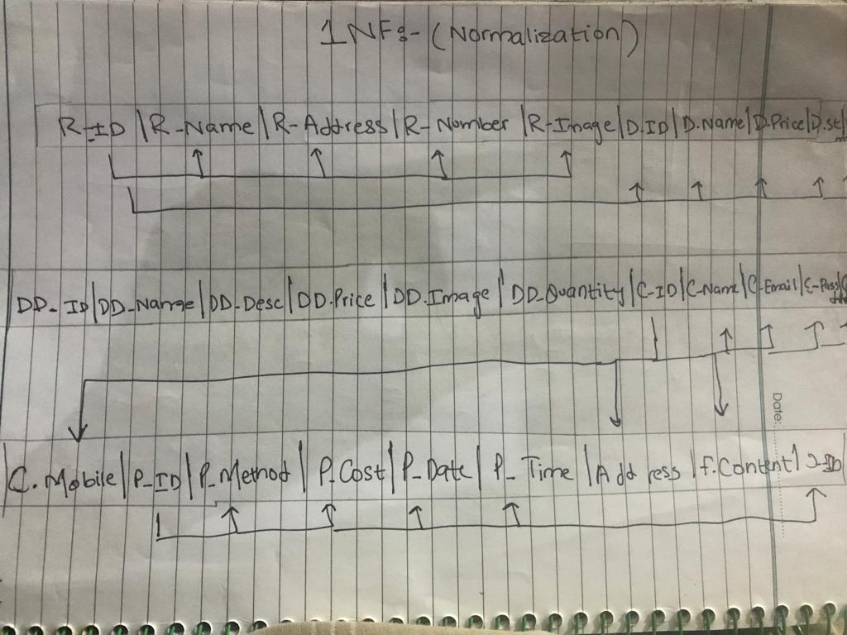

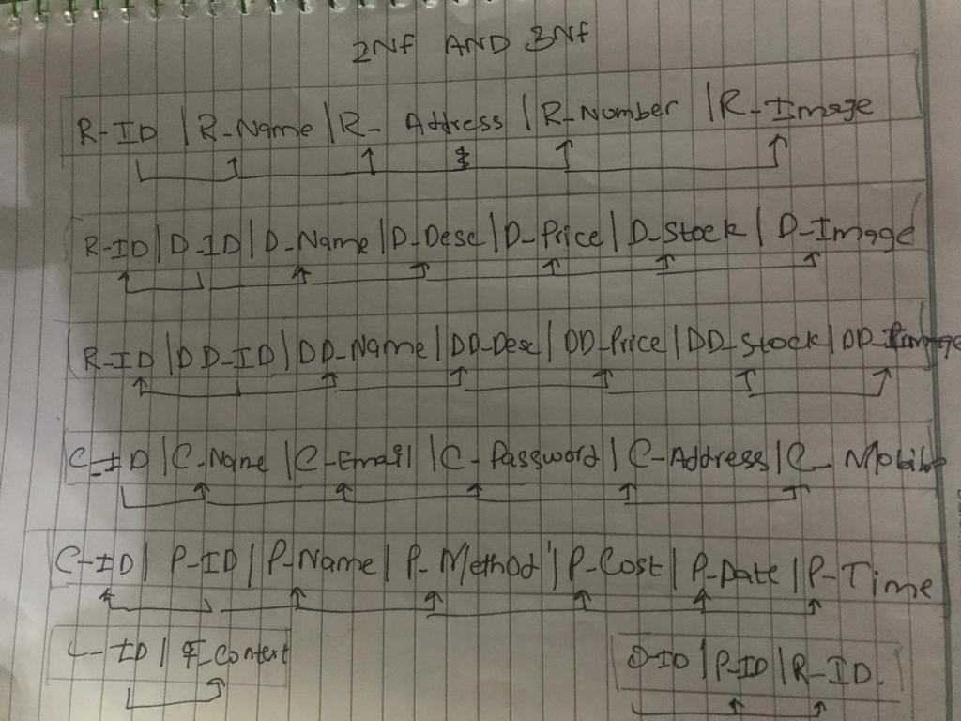

# DESCRIPTION:

ADMIN:-

**EXTERNAL INTERFACE REQUIREMENTS:**

**Software interface:**

There would be separate apps for admin for restaurant entry and the customers to order the food however it would be maintaining the style throughout the site by header and footers for both admin and the users there would be fixed header and footer for software interfaces our front end is on html css and backend on php and mysql server database is designed abasic web browser will also be needed.

**Hardware interface:**

We would be using basic essential hardware components for our software maintain A mobile device and nothing else . on the contrary an ipad a computer and pther divices supporting web will be supported.

**Communication interface:**

The mean of internet communication would be used are

* Emails
* Social media
* Credit card

**NON-FUNCTIONAL REQUIREMENTS:**

**Performance Requirements:**

The website would be providing maximum fotality as per our research it would be responsive and easy and faster access for the user is being proclaimed there would be minimal time difference between user and the restaurants .

**Safety Requirements:**

As for every business data is the foremost key hence in order to maintain data and avoid data loss precautions have been taken .

**Security Requirements:**

For safety security reasons we have encrypted the users password that even the oraganization will not be able to decode that by a build in php function of md5 the user have only access to payment without his/her approval payment cannot be accessed.

**User Documentation:**

User would be given receipt of every order hence the user will also be having our support and intro page which would be defining the user how to use the website in any query help would always be avalaible if user inserts or do wrong approach an alert would be generated inorder to guide the user

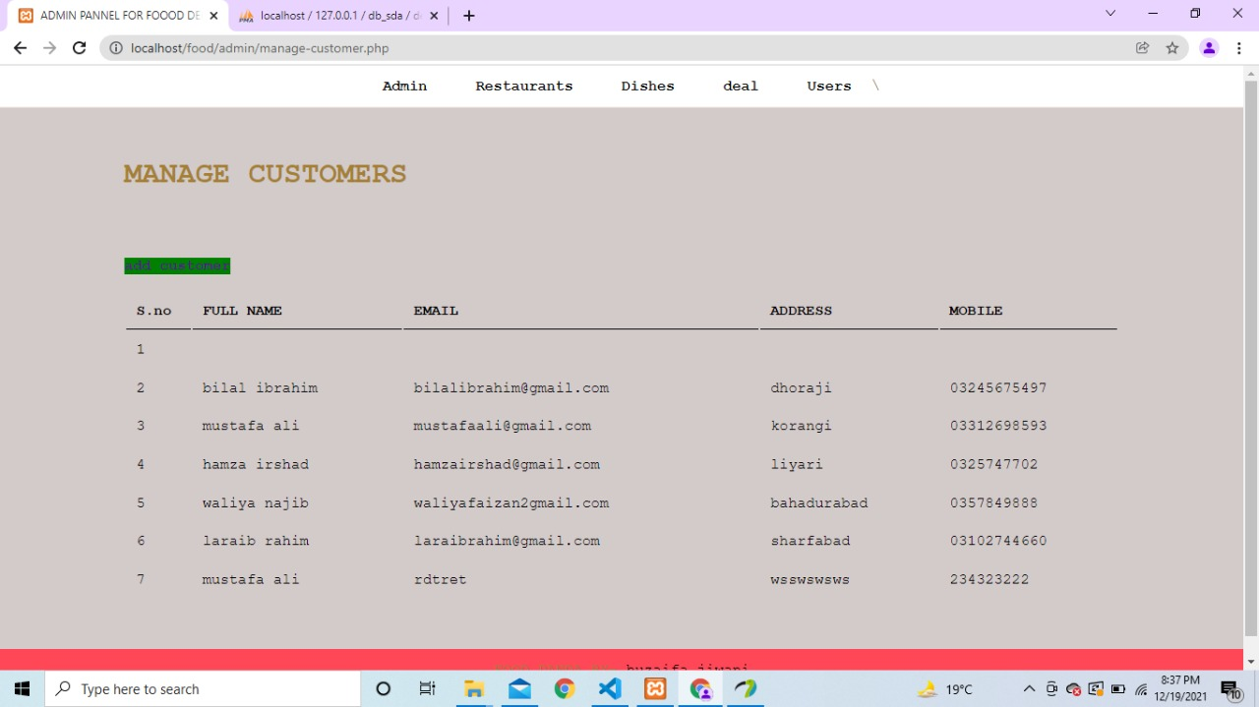

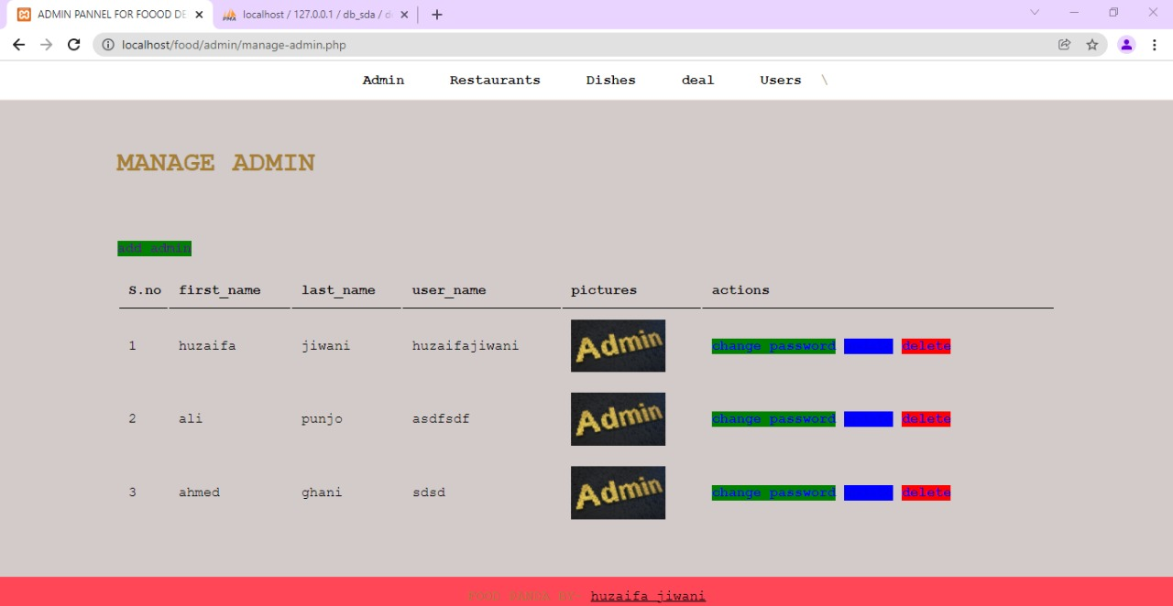

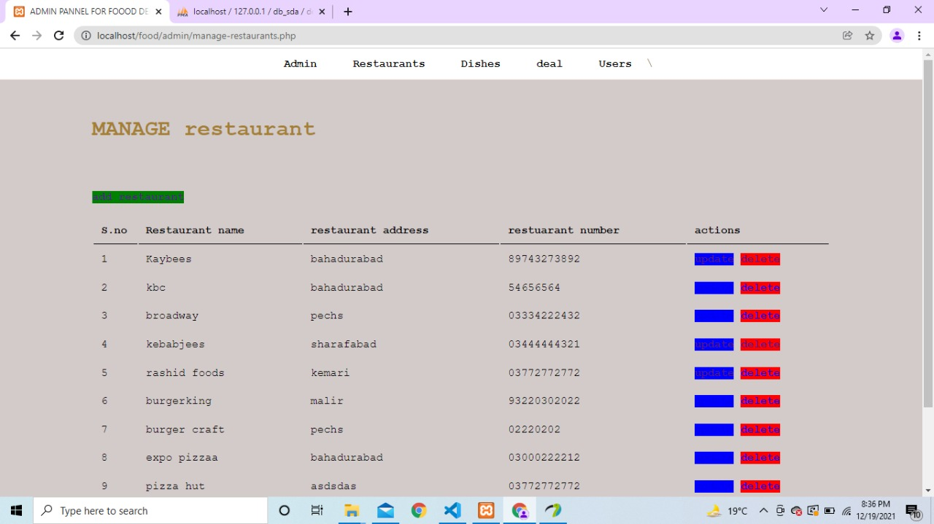

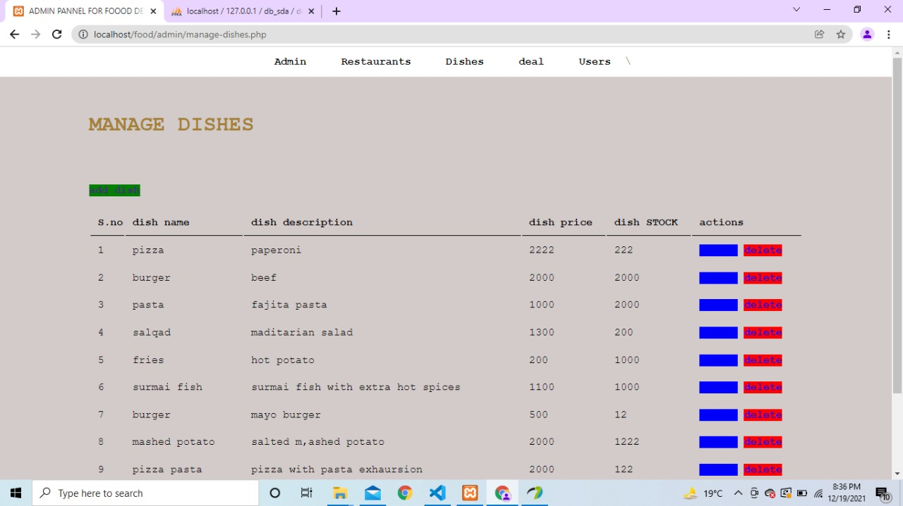



**USER:-**

**Description:-**

Customer can first sign in in the account to select the restaurant what they want. They select the menu by tapping add to cart total price gets sum with this selected price and shows to the user.

Customer can remove an item from list and total amount gets decremented and then we click the checkout button now it suddenly gets the payment feature and then account details of the user who is logged in

**1st PHASE:-**

**LOGIN**

**SIGNUP**

**SELECT RESTAURANT**

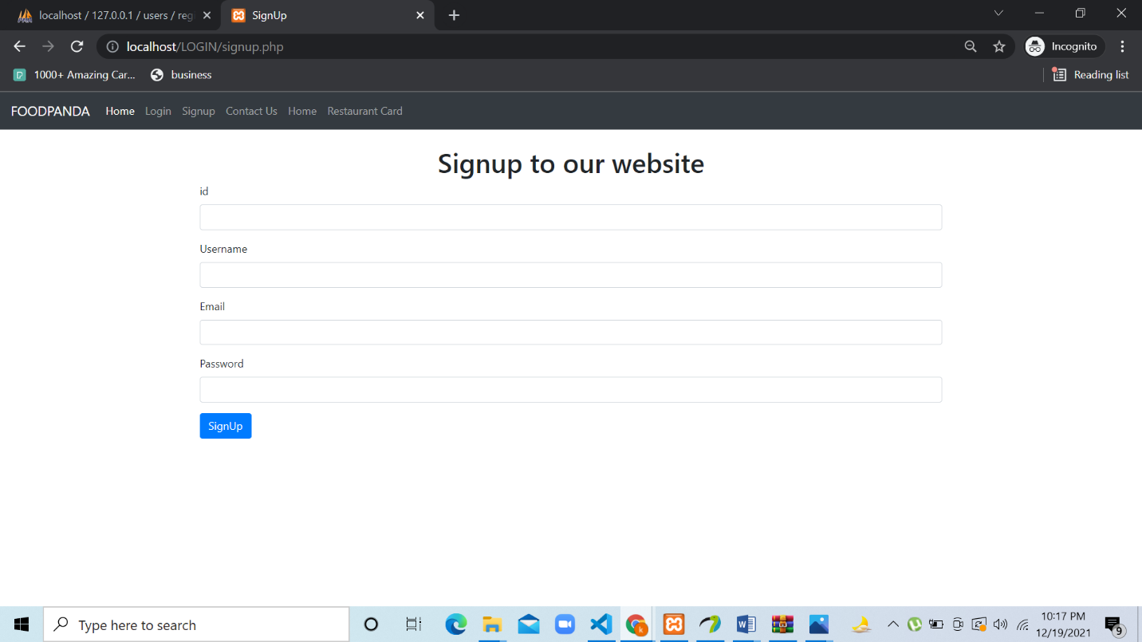

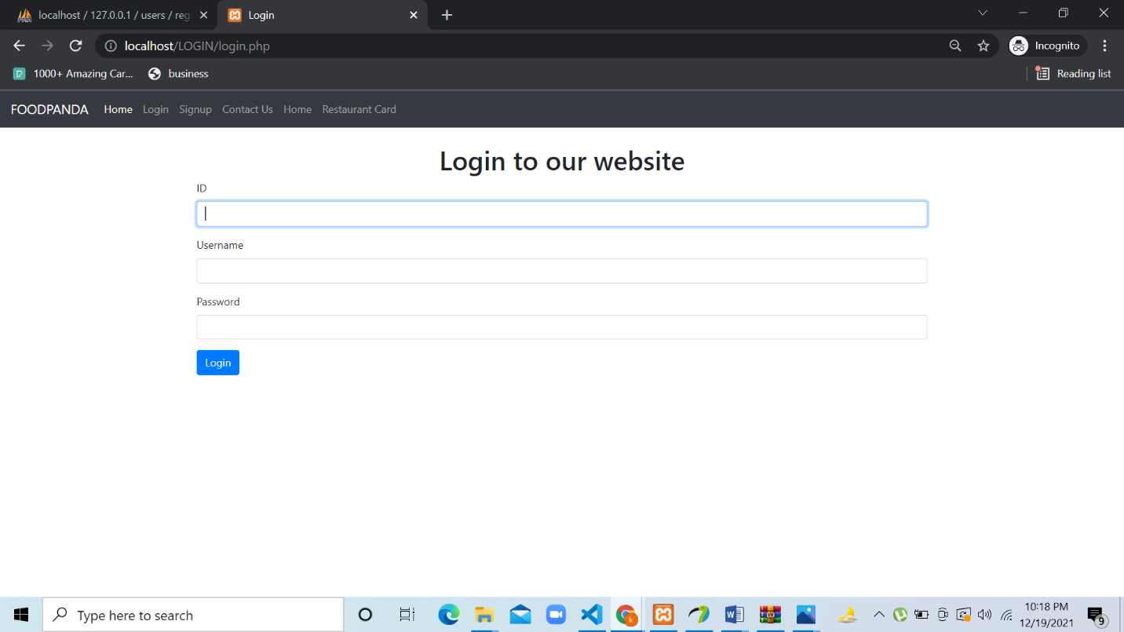

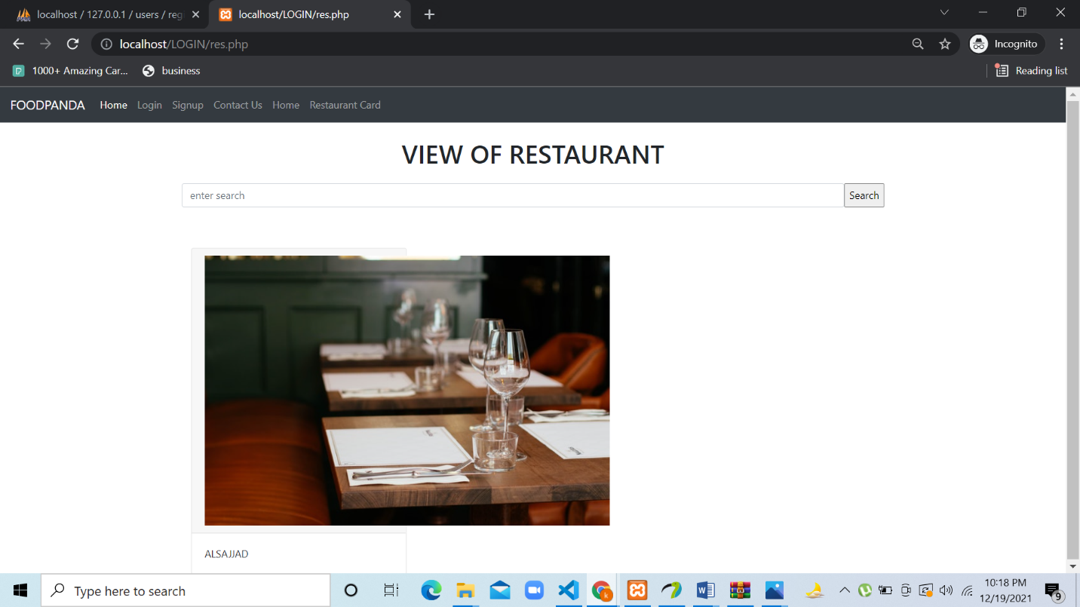

**2ND PHASE:-**

**SELECT MENU**

**ADD TO CART**

**REMOVE AN ITEM IF WANTS**

**PAYMENT FEATURE**

**ACCOUNT DETAILS**



